Evidencing the Impact of Primary PE and Sports Premium at
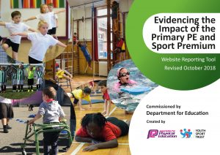
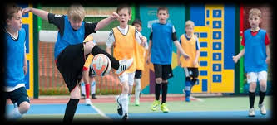
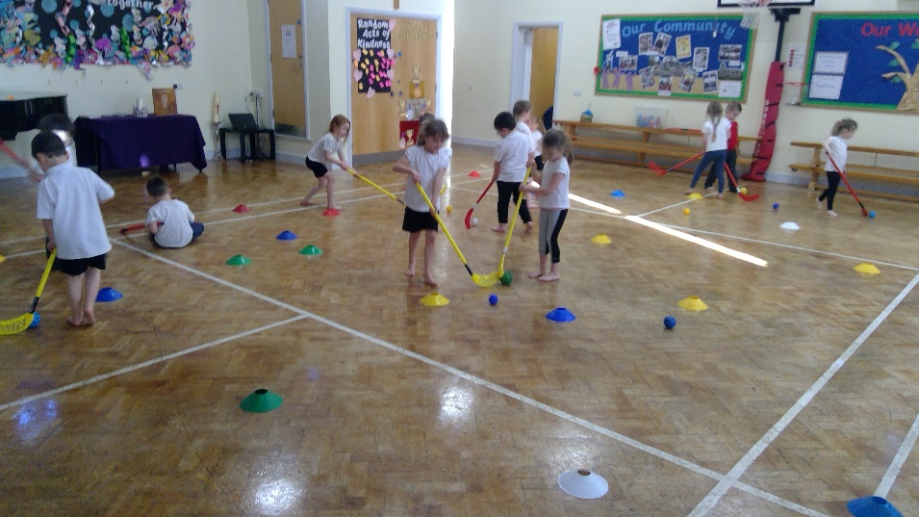
Leverton Church of England Academy

Leverton Church of England Academy believes physical education is an essential and integral part of a child’s educational development. The core components of the curriculum centre on movement, key skills and social interaction. We believe that physical education should teach children to recognise the diversity of individual ability whilst helping them to understand that participation in sport is just as important as gaining success from it.

Our aim is to develop a ‘can do mindset’ amongst our children. We want them to strive for excellence and to make the most of their sporting abilities. But we also recognise the importance of teaching the children how to show the correct sportsmanship, and how to demonstrate respectful conduct and fair play.

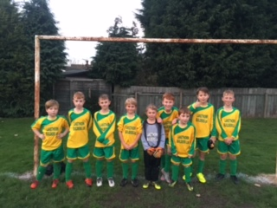
Developing a balanced Physical Education programme, offering a variety of activities, provides children with the opportunity to develop acceptable fitness levels, a broad spectrum of skills and the knowledge necessary to use those skills for a lifetime of active participation. We feel positive participation in PE will leave children with a legacy of success, facilitating a active lifestyle.

Vision and Aims for PE

At Leverton Church of England Academy we share The Department for Education’s Vision for the Primary PE and Sports Premium:

For all pupils leaving primary school to be physically literate and with the knowledge, skills and motivation necessary to equip them for a healthy, active lifestyle and lifelong participation in physical activity and sport.

The funding has been provided to ensure impact against the following objective:
To achieve self-sustaining improvement in the quality of PE and sport in primary schools.
It is important to emphasise that the focus of spending must lead to long lasting impact against the vision (above) that will live on well beyond the Primary PE and Sport Premium funding.

It is expected that Leverton Academy will see an improvement against the following 5 key indicators:
- the engagement of all pupils in regular physical activity – kick-starting healthy active lifestyles
- the profile of PE and sport being raised across the school as a tool for whole school improvement
- increased confidence, knowledge and skills of all staff in teaching PE and sport
- broader experiences of a range of sports and activities offered to all pupils
- increased participation in competitive sport

HOW TO USE THE PRIMARY PE AND SPORT PREMIUM

Schools must use the funding to make additional and sustainable improvements to the quality of PE and sport they offer. This means that you should use the premium to:
- develop or add to the PE and sport activities that your school already offers
- make improvements now that will benefit pupils joining the school in future years For example, you can use your funding to:
- hire qualified sports coaches to work with teachers
- provide existing staff with training or resources to help the teach PE and sport more effectively
- introduce new sports or activities and encourage more pupils to take up sport
- support and involve the least active children by running or extending school sports clubs, holiday clubs and Change4Life clubs
- run sports competitions
- increase pupils’ participation in the School Games
- run sports activities with other schools

- You should not use your finding to:
- employ coaches or specialist teachers to cover PPA arrangements – these should come out of your core staffing budget
- teach the minimum requirements of the national curriculum – including those specified for swimming.

Swimming & Water Safety

Swimming in an important skill and can encourage a healthy and active lifestyle.
The programme of study for PE sets out the expectation that pupils should be taught to:
- swim competently, confidently and proficiency over a distance of 25 meters
- use a range of strokes effectively
- perform safe self-rescue in different water based situations

Swimming and Water Safety

- What percentage of Year 6 pupils could swim competently, confidently and proficiently over a distance of at least 25 meters when they left primary school at the end of the last academic year? | 81%
- What percentage of Year 6 pupils could use a range of strokes effectively (for example front crawl, backstroke & breaststroke) when they left primary school at the end of the last academic year? | 69%
- What percentage of Year 6 pupils could perform a safe self-rescue in different water based situations when they lest primary school at the end of the last academic year? | 81%
- Schools can use the Primary PE and sport premium to provide additional provision for swimming but this must be for activity over and above the national curriculum requirements. Have you used it in this way? | Booster swimming sessions

Academic Year: 2018/19 |  |  |  | Total funds allocated:  £16,930
Key indicator 1: The engagement of all children in regular physical activity – the Chief Medical Officer guidelines recommended that all children engage in at least 30 minutes of physical activity a day in school |  |  |  | Percentage of total allocation:  £3260 = 19%
Intention | Implementation |  | Impact
School focus with clarity on intended impact: | Actions to achieve: | Funding allocated: | Evidence of impact: | Sustainability & suggested next steps:
To maximise the engagement and activity of all children within the classroom & at play/lunch times. | 1. Introduce daily ‘get moving’ sessions in all classrooms (10 min am/pm & 10 min active learning = 30 min)  2. Train ‘girls active’ playground leaders to run lunchtime & afterschool clubs  3. TA lunchtime support for active games (15 min per day)  4. Active breakfast club  5. Active Twilight club afterschool once a week | £500  £50  £450  £1930  £330 | * Observations show all classes participating in ‘get moving’ sessions daily, therefore hitting the 30 min daily requirement  * Pupil voice questionnaires showed that children enjoy the active/yoga sessions at the start of the day/afternoon & understood the importance of being active  * Girls active clubs are up and running more girls are now active during these lunchtime sessions – 43% increase in participation  * attendance at breakfast club has increased from average of 12 children to average of 27 a day – all join in the active element of the club | Continue to have active session for 10 minutes every morning & afternoon – further develop staff training on active learning session  Continue girls active sessions – train Y5 girls for sustainability  Develop the TA lunchtime provision further – train more sports leaders to run the games from across KS2

Academic Year: 2018/19 |  |  |  | Total funds allocated:  £16,930
Key indicator 2: The profile of PE and sport being raised across the school for whole school improvement |  |  |  | Percentage of total allocation:  £4461 = 26%
Intention | Implementation |  | Impact
School focus with clarity on intended impact: | Actions to achieve: | Funding allocated: | Evidence of impact: | Sustainability & suggested next steps:
To increase the engagement in activity across the school.  To increase the take up in after school sporting clubs.  To engage in more cross school competitions & festivals.  To achieve the Gold school games mark award | 1. Introduce ‘girls active’ & sports leaders at lunchtimes  2. Develop the variety of after school sports clubs  3. Join the Bassetlaw sports partnership package for cross school opportunities to enjoy a range of sports  4. Develop the school sports board to celebrate & share activities  5. Continue to run Healthy lifestyle education lessons for all children (including drug awareness for Y5/6) & food growing lessons | £50 (KI 1)  £400  £765  N/A  £3296 | *23% of children are sports leaders across the school & have engaged target children in joining their clubs  *80% of the target children are now involved in regular activity  *A range of new sports/festivals have been experienced via the games package, including specific sessions for SEND pupils, therefore increasing participation & engagement  *77% of children have taken part in at least 1 after school active club during the academic year.  *School sporting successes, both team & individual, are shared on the sports board & in celebration assembly  *85% of children assessed at the age related level or above in Healthy lifestyles education  *Gold games mark achieved | Continue girls active sessions – train Y5 girls for sustainability  Improve after school sporting provision by employing external providers to offer additional sports for further participation  Develop more opportunities for children to play/compete against other school to support confidence in sport  Further develop outdoor learning linked to growing and forest education

Academic Year: 2018/19 |  |  |  | Total funds allocated:  £16,930
Key indicator 3: Increase confidence, knowledge and skills of staff teaching PE and sport |  |  |  | Percentage of total allocation:  £7800 = 43%
Intention | Implementation |  | Impact
School focus with clarity on intended impact: | Actions to achieve: | Funding allocated: | Evidence of impact: | Sustainability & suggested next steps:
To increase the confidence of all staff in the teaching and delivery of the PE curriculum | 1. PE coach to work alongside the school staff to deliver a range of sports – focus on developing fundamental skills & approaches to building into specific sports/games  2. Staff PE courses  3. Training for TA/middays on developing & leading lunchtime sports clubs with the sports leaders | £7000  £200  £100 | *80% of staff reported an increase in their confidence in delivering PE after working alongside the specialist coaches  *100% of staff reported they had a greater understanding of how skills can be built within a sequence of lessons  *PE leader attended active learning course – feed into CPD next year  *100% of midday staff are more confident in delivering active lunchtime games & more children are engaged | *coach to continue to support staff development – introduce new sports on a rolling programme (Autumn term all classes fundamental skills)  *Active learning CPD session delivered by PE leader  * further develop active zones at lunchtime & train sports leaders to deliver in each area

Academic Year: 2018/19 |  |  |  | Total funds allocated:  £16,930
Key indicator 4: Broader experience of a range of sports and activities for all pupils |  |  |  | Percentage of total allocation:  £1416 = 8%
Intention | Implementation |  | Impact
School focus with clarity on intended impact: | Actions to achieve: | Funding allocated: | Evidence of impact: | Sustainability & suggested next steps:
Enable a broader range of sports to be offered | 1. employ specialists coaches to work alongside the staff and introduce new sports  2. Join the Bassetlaw sports partnership to experience new sports and competitions/ festivals  3. Y6 top up swimming  4. New equipment to support range of sports | £7000 (KI 3)  £765 (KI 2)  £666  £750 | *New sports introduced – Tchoukball, La Crosse & Tag Rugby. Developed handball, hockey and ball skills with EYFS  *Staff confidence has increased (KP 3)  *A range of new sports/festivals have been experienced via the games package, including specific sessions for SEND pupils, therefore increasing participation & engagement  *71% of children have taken part in a school package event this academic year | *coach to continue to support staff development – introduce new sports on a rolling programme (Autumn term all classes fundamental skills)  *Target increased participation in school package events & cross school opportunities – aim for all children to experience at least 1 event 2019/20

Academic Year: 2018/19 |  |  |  | Total funds allocated:  £16,930
Key indicator 5: Increase participation in competitive sport |  |  |  | Percentage of total allocation:  £500 = 3%
Intention | Implementation |  | Impact
School focus with clarity on intended impact: | Actions to achieve: | Funding allocated: | Evidence of impact: | Sustainability & suggested next steps:
To enable more children to participate in school competitions and fixtures across a broader range of sports | 1. Bassetlaw sports fixture package used to engage in more competitions/festivals  2. Transportation via school minibus to support wider range of sporting opportunities | £765 (KI 2)  £500 | *71% of children have taken part in a school package event this academic year  *School Football team successfully won the league | *Target increased participation in school package events & cross school opportunities – aim for all children to experience at least 1 event 2019/20  *Develop more in school competitions

